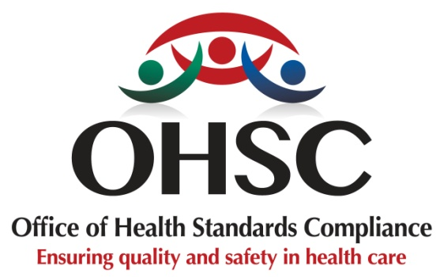

BACKGROUND INFORMATION FOR COMMUNITY MEMBERS / HEALTH USERS
REVIEW OF THE RULES FOR SAFE AND GOOD HEALTHCARE

1. Why are the rules being reviewed?
The Office of Health Standards Compliance (OHSC) is reviewing the rules that healthcare facilities must follow to provide safe and good healthcare.
These rules were introduced in 2018 and have been used to assess whether healthcare facilities are providing safe, high-quality care.
Healthcare has changed over the years. We have also learnt more about what is needed to keep patients safe and improve the quality of healthcare.
The review is being done to make sure that the rules:
- are clear and easy to understand;
- help healthcare facilities provide safe and good quality care;
- protect patients from harm;
- take into account the different types of healthcare facilities;
- help healthcare workers and managers know what is expected of them; and
- support better healthcare for everyone.
The review is also an opportunity for patients, families, healthcare workers and communities to share their views about what needs to improve.
2. What is the OHSC?
The Office of Health Standards Compliance (OHSC) is a government health regulator established under the National Health Act.
The OHSC works to protect people who use health services by checking whether healthcare facilities follow the rules for safe, high-quality healthcare.
The OHSC does this by:
- inspecting healthcare facilities;
- checking whether facilities meet the required rules;
- taking action where facilities do not meet the rules;
- dealing with complaints about healthcare facilities that do not meet the required rules; and
- advising the Minister of Health on rules that can help improve the quality and safety of healthcare.
The OHSC checks healthcare facilities across South Africa, including public and private facilities.
3. Why do the rules need to change?
The current rules came into effect in February 2019. Since then, the OHSC has inspected many healthcare facilities and has learned more about the challenges faced by both patients and healthcare workers.
The inspections have shown that some areas of the rules need to be clearer or strengthened.
For example, the review will look at:
- keeping healthcare facilities clean and preventing infections;
- making sure patients receive care that respects their needs and dignity;
- making sure medicines are available and managed properly;
- making sure problems that could harm patients are reported and dealt with; and
- improving the way the quality of healthcare and patient outcomes are measured.
The review will also consider the different needs of clinics, community health centres, hospitals and other healthcare facilities.
4. What is the aim of the review?
The main aim is to ensure that people receive safe, quality and respectful healthcare, wherever they receive care.
The review aims to:
- strengthen patient safety;
- improve the quality of healthcare;
- make the rules clearer and easier to apply;
- make sure healthcare facilities are treated fairly and consistently;
- make sure the rules are suitable for different types of healthcare facilities; and
- bring the rules in line with current healthcare needs and good practices.
The review is not only about adding more rules. It is about ensuring that the rules healthcare facilities must follow are clear, practical, and focused on patient safety and well-being.
5. Who is helping with the review?
The OHSC is working with people and organisations from different parts of the healthcare sector. A National Technical Working Group was established to support the review. It includes representatives from:
- the National Department of Health;
- provincial health departments;
- the Hospital Association of South Africa;
- the Unity Forum for Family Practitioners; and
- the Office of Health Standards Compliance.
The group brings together people with knowledge and experience in healthcare. They are helping to review the current rules and identify where changes may be needed.
The group is also reviewing information from inspections, healthcare quality reports, and other relevant sources.
6. Why is public and community participation important?
The review is not only for government and healthcare professionals. Patients, families and communities are also an important part of this process.
People who use healthcare services know what they experience when they visit a clinic, community health centre, hospital or other healthcare facility.
Their views can help the OHSC understand:
- what is working well;
- what problems people experience when receiving healthcare;
- what makes people feel safe or unsafe when receiving care;
- how healthcare workers treat patients;
- what improvements are needed; and
- what communities expect from healthcare facilities.
The OHSC will therefore engage with communities, patients, healthcare workers and other stakeholders across the country.
7. How can people have their say?
People will have opportunities to take part in the review through different forms of engagement, including:
- community meetings and roadshows;
- public consultations;
- workshops;
- online meetings and webinars; and
- written comments and submissions.
Community members are encouraged to ask questions, share their experiences and give their views. All contributions will help inform the review process. The OHSC will consider the views received as it works towards finalising the revised rules.
8. What can communities expect from the review?
The review is intended to contribute to healthcare that is:
Safe – patients are protected from avoidable harm.
Good quality – people receive the care they need.
Respectful – patients are treated with dignity and respect.
Fair – people should receive the same standard of care regardless of where they live or which healthcare facility they use.
Accountable – healthcare facilities must take responsibility for meeting the rules for safe and good healthcare.
9. The message to communities
The review of the rules is about improving healthcare for people.
Your experience matters.
Your voice can help us understand what needs to change and what should be improved.
The OHSC encourages patients, families and communities to take part in the consultation process and share their views on how healthcare can be made safer and better for everyone.

For more information, email: standardsreview@ohsc.org.za

