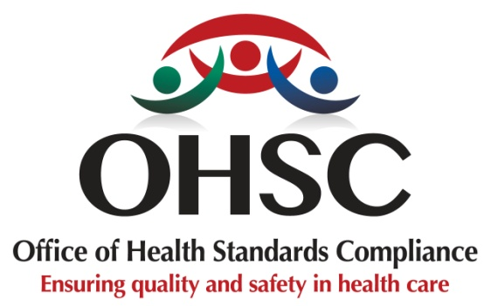

FREQUENTLY ASKED QUESTIONS
Review of the 2018 Norms and Standards Regulations
Community Consultation on Draft 1

A. ABOUT THE REVIEW
1. What are the Norms and Standards Regulations?
The Norms and Standards Regulations, also known as health standards, are the rules that healthcare facilities must follow to provide safe and quality healthcare.
They help ensure that people receive proper care and are treated with dignity and respect when they use health services.
2. Why are the rules for safe and good healthcare being reviewed?
The current Norms and Standards Regulations were introduced in 2018 and came into effect in 2019. Since then, the healthcare system has changed, and we have learned from inspections and people's experiences of healthcare.
The review is intended to strengthen these health standards and make sure they continue to support safe, quality and people-centred healthcare.
3. What does this review mean for me as a patient or healthcare user?
The review focuses on making healthcare safer and improving the experience of health services.
The proposed health standards cover issues such as waiting times, access to healthcare, medicines, cleanliness, safety, privacy, dignity, complaints and the information given to patients.
4. What are my rights when I use a healthcare service?
You have the right to be treated with dignity and respect and to have your privacy protected.
You should also receive information about the healthcare services available to you, understand your treatment and be able to raise concerns or make a complaint when you are unhappy with the care or service you receive.
.

5. Will waiting times be addressed?
Yes. The proposed health standards require healthcare facilities to track waiting times and take steps to reduce unnecessary delays.
People should also be given information about waiting times for certain services.
6. Will the health standards help to make healthcare safer?
Yes. The health standards for safe and good healthcare include measures to prevent patient harm.
These include preventing infections, reducing medication errors, improving emergency care, and learning from incidents in which patients may have been harmed.
7. Will the cleanliness and safety of healthcare facilities be addressed?
Yes. The proposed health standards cover areas such as cleanliness, infection prevention, waste management, water, electricity, fire safety, ventilation, and the condition of healthcare facilities.
These are important to help keep patients, visitors and healthcare workers safe.
B. HAVING YOUR SAY
8. Why is the community being asked for its views?
People who use healthcare services know from their own experience what works well and what needs to improve.
Your views can help ensure that the rules healthcare facilities must follow to provide safe, high-quality healthcare respond to the needs of patients and communities.
9. What can I give my views about?
You can speak about anything in the proposed rules that affects you or your community when using healthcare services.
For example, you can tell us about:
- waiting times;
- how patients are treated;
- privacy and dignity;
- access to healthcare services;
- medicines and treatment;
- cleanliness and infection prevention;
- how complaints are handled;
- information given to patients; and
- your overall experience of receiving healthcare.
You can also tell us if you think something important is missing.
10. Can I take part if I do not have a computer, smartphone or internet?
Yes. You do not need a computer or internet access to have your say.
You can share your views during the community consultation sessions. You will have an opportunity to raise your concerns, share your experiences and make suggestions.
The consultation team will explain how your views will be recorded and submitted.
11. Will my views be heard?
Yes. The concerns, experiences and suggestions raised during the consultation will be recorded and considered as part of the review.
Not every suggestion may be included, but all views will be considered before the health standards for safe and good healthcare are finalised.
12. What happens after the consultation?
The views received from communities, patients and other groups will be considered as the review continues.
Changes may be made to the proposed health standards based on the feedback received and the required process.
13. Are these new health standards already in place?
No. The document being discussed is Draft 1. It is not the final version of the rules.
This consultation allows patients, communities and other stakeholders to comment before the revised health standards are finalised.
14. When will the new health standards take effect?
The revised health standards will only take effect after the required process has been completed and they have been published in the Government Gazette.
15. Why should I take part?
Your experience matters.
By taking part, you can tell us what is working well, what needs improvement, and what should be considered when setting the health standards that healthcare facilities must meet to provide safe, high-quality healthcare.
Your voice can help improve healthcare for you, your family and your community.

For more information, email: standardsreview@ohsc.org.za
Follow the discussion on social media @OHSCSOCIALMEDIA

