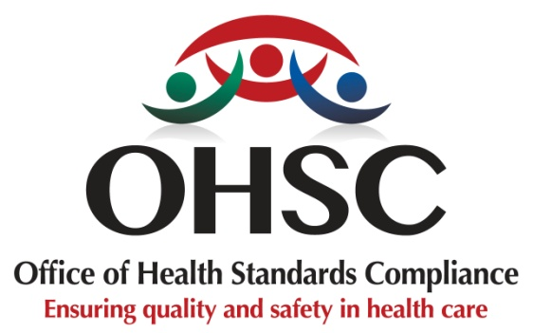

INFORMATION ON THE REVIEW OF THE NORMS AND STANDARDS REGULATIONS

- EXECUTIVE SUMMARY
In January 2022, the Office of Health Standards Compliance (OHSC) submitted a report of recommendations to the National Department of Health (NDOH) proposing revisions to the regulations. This was followed by a presentation of the proposal to the NDOH Senior Management Team on 24 August 2024, at which consensus was reached to proceed with a structured review process. It was agreed that the process would be led by a Technical Working Group (TWG) convened by the OHSC, with active participation from key stakeholders across the health sector.
Following the consultation process, with the NDoH as the custodian of the regulations, the Office of Health Standards Compliance (OHSC) initiated a comprehensive review of the current norms and standards regulations promulgated in 2018 for health establishments to ensure they remain responsive to evolving health system reforms, emerging patient safety risks, and advances in clinical practice.
The review seeks to strengthen the clarity, measurability, and enforceability of compliance requirements, while aligning regulatory expectations with national health priorities and internationally recognised best practices in healthcare quality and safety.
Through a transparent, consultative process with key stakeholders across the health sector, the revised norms and standards aim to improve the quality of care, reinforce accountability, and strengthen public confidence in South Africa’s healthcare system. The review will also support the broader national agenda to improve health system performance and ensure consistent, safe, and patient-centred care across all health establishments.

- INSTITUTIONAL CONTEXT
The OHSC was established in terms of the National Health Act, No. 61 of 2003 (as amended), to protect and promote the health and safety of users of health services by monitoring and enforcing compliance with prescribed norms and standards in healthcare establishments across South Africa.

The OHSC fulfils its mandate by monitoring and enforcing compliance with the norms and standards prescribed by the Minister of Health, and by ensuring the consideration, investigation, and disposal of complaints relating to non-compliance with those norms and standards in a procedurally fair, economical, and expeditious manner.

Under Section 79 of the NHAA, the OHSC must or may further advise the Minister on matters relating to norms and standards for the national health system, the review of such norms and standards, or any other matter referred to it by the Minister.

As the country advances broader health system reforms and strengthens its focus on quality assurance and patient safety, the OHSC plays a critical role in ensuring that regulatory frameworks remain relevant, evidence-based, and responsive to emerging challenges in healthcare delivery.
The review of the Norms and Standards Regulations is therefore aligned with the OHSC’s statutory mandate to promote safe, high-quality healthcare and to continuously improve the effectiveness of regulatory oversight within the health system.

- BACKGROUND AND RATIONALE FOR THE REVIEW
The Minister of Health promulgated the current Norms and Standards Regulations in February 2018 and came into effect in February 2019.
Following the promulgation of the regulations, the OHSC initiated a phased implementation approach. Inspections of public healthcare clinics commenced during the 2019/20 and 2020/21 financial years on an incremental basis, while inspection tools for other levels of care were progressively developed and implemented.
During the development of inspection tools and the subsequent implementation of the regulations, certain limitations were identified in the scope and specificity of some requirements relating to healthcare quality and patient safety.
These include, among others:
- More detailed infection prevention and control requirements in specialised units such as neonatal care units
- Stronger emphasis on patient-centred care
- Improved provisions relating to medication availability and management across different levels of care
- More explicit requirements for the reporting and management of patient safety incidents
These gaps were anticipated to some extent, as the initial Norms and Standards Regulations were designed to establish a foundational regulatory framework rather than to comprehensively address all aspects of quality and safety in health service delivery.
This review, therefore, aims to:
- strengthen the regulatory framework by addressing identified gaps and limitations, ensuring that the norms and standards are robust, risk-informed, and responsive to the evolving healthcare environment
- enhance the comprehensiveness and applicability of the regulations across a wider range of health establishment categories, including the measurement of health outcomes
- Strengthen patient safety and clinical outcomes
- Enable consistent, fair, and enforceable regulation
- Align with global best practices and local realities
- Support system-wide reliability and resilience

- Technical Review Process
Following consultation and agreement with the National Department of Health (NDoH), a National Technical Working Group (NTWG) was established to guide the review of the Norms and Standards Regulations. The TWG comprises representatives from:
- National Department of Health
- Provincial Departments of Health
- Hospital Association of South Africa (HASA)
- National Hospital Network (NHN)
- Clinix Health Group
- Unity Forum for Family Practitioners
- Office of Health Standards Compliance
Members of the NTWG were nominated based on their technical expertise and sector representation. The group is responsible for supporting the technical review of the existing norms and standards and ensuring that proposed revisions are evidence-informed, practical, and aligned with current health system needs.
Key responsibilities of the NTWG include:
- Conducting a comprehensive review of the existing norms and standards
- Reviewing relevant national and international regulatory frameworks and best practices
- Analysing inspection findings, quality improvement reports, and other relevant evidence
- Developing a Social and Economic Impact Assessment Study (SEIAS) to accompany the proposed regulatory amendments
- Contributing to the development of a structured framework for reviewing norms, standards, and regulations
These activities are intended to ensure that the revised regulations are robust, implementable, and responsive to the operational realities of healthcare establishments.

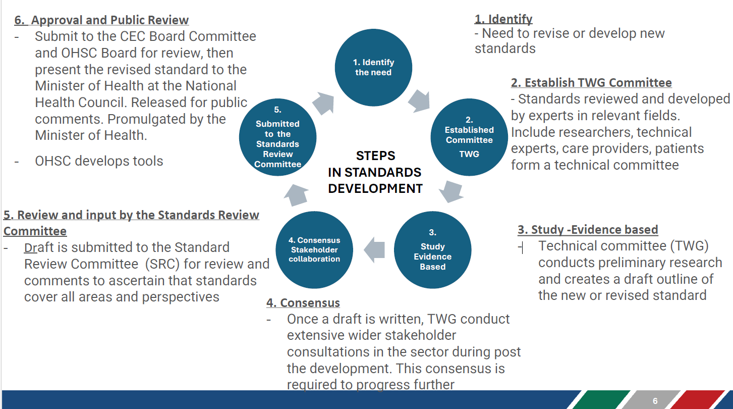
Sequence of Activities

- Stakeholder Engagement, Impact and Expectation
Stakeholder engagement is a critical component of the review process, ensuring that regulatory reforms are evidence-informed, practical, and responsive to the realities of healthcare delivery.
The review is expected to have system-wide implications, as it seeks to refine compliance expectations, strengthen patient safety requirements, and improve regulatory clarity across all levels of healthcare.
Engagements, including roadshow, will therefore be undertaken with a broad range of stakeholders, including:
- healthcare providers across the public and private sectors
- professional councils and professional associations
- provincial health departments
- general public, hospital groups, and primary healthcare organisations
- patient advocacy groups and civil society organisations
- policymakers and health system leaders
- academic and training institutions
- trade unions
- media
These engagements aim to promote sector-wide ownership of the revised norms and standards, reduce resistance to regulatory change, and enhance compliance by ensuring that the regulatory framework reflects both patient safety priorities and operational realities across diverse healthcare settings.
To ensure effectiveness, stakeholder engagements will be structured, inclusive, and conducted in phases. Activities will include:
- early-stage consultations to identify key review priorities
- publication of discussion documents for public comment and written submissions
- targeted discussions through various platforms such as technical workshops, webinars, public engagements, etc., with key sector stakeholders
- engagements with community and patient representatives
- dissemination of feedback reports demonstrating how stakeholder inputs have informed the proposed revisions
During engagement sessions, stakeholders are encouraged to participate constructively by providing evidence-based inputs, identifying implementation challenges, and highlighting potential unintended consequences of proposed regulatory changes.
Stakeholder engagements will therefore serve not only as a consultative mechanism but also as a collaborative process to ensure that the revised norms and standards regulations are practical, enforceable, and capable of strengthening the quality and safety of healthcare delivery across South Africa.

For more information, email: standardsreview@ohsc.org.za

